Honouring The Ancient Dead
Ensuring Respect for the Ancestors

Honouring the Ancient Dead
Shropshire
SY05 0AR
T. 07401 387053
E. office@honour.org.uk

May 2026
Fourth Edition v4

Reburial Handbook
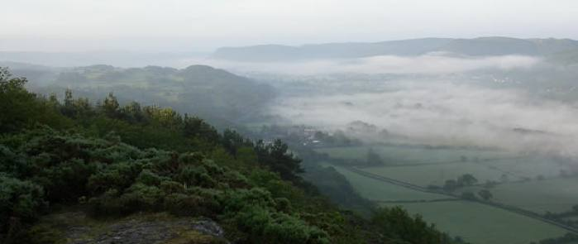

Table of Contents
Introduction 5
Purpose of this Handbook 5
HAD’s Position 6
HAD’s Foundation and Aims 6
Structure of this Handbook 6
Using this Handbook 7
Strategies for Reburial 11
The Deceased in Your Care 11
Policies in Place 11
Interested Parties 12
Consultation Process 13
Reburial Process 17
How To Rebury: Step-by-Step Practicalities 23
Finding a Burial Site 23
Containers 25
Funeral Directors 26
The Rite of Committal for Reburial 27
Celebrant 28
Grave Goods 28
Publicity 29
Concluding Documentation 29
Appendix A: Committal Rite for Reburial 33
Appendix B: Highworth Reburial 37
Appendix C: Burial of Bones used for Medical Education 41
Appendix D: Burial Record for a Privately-Owned Burial Ground 44

Introduction

Purpose of this Handbook
This handbook is intended to be a source of information and recommendations that we hope will be helpful to anyone considering or intending to rebury what are generally termed ‘human remains’: the bones, ash or other bodily evidence of human or hominid ancestors, generally over one hundred years old, that have found their way into collections and stores in museums, archaeological units, historical societies, universities, teaching hospitals and elsewhere.
The primary audience of the handbook is archaeologists, museum professionals, medical professionals and others who are thinking about reburial (or, where interment has never taken place, burial), have made the decision to do so or are considering whether it may be possible, and now need practical information about how to go about it. As such, this handbook picks up where other guides, such as the Museums Association Disposal Toolkit, stop in their advice. In particular, it provides advice on ways of minimising the costs of reburial and provides information and sources of support.
Importantly, the remit of this handbook is the deceased of British provenance. Intentionally it does not cover policies or procedures relevant to human remains that were brought to the UK from overseas, where that provenance is known. However, where the provenance is not known, thus repatriation is not an option, the guidance here in this handbook could be very helpful.
HAD recognises the enormous challenges facing museums, other heritage organisations and publicly funded bodies. However, through initiatives such as reburial, organisations can gain significantly, not only by reducing liabilities with regard to storage of human remains, but also through valuable engagement with local communities.
The Museums Association ‘Code of Ethics’ (2025) advocates for open, transparent and accountable processes, including the need to build constructive relationships with a variety of partners and interested parties. Our handbook supports the implementation of the MA ‘Code of Ethics’ through clear and actionable steps for reburial of ancestral remains.
The focus of this handbook is on reburial and so, necessarily, omits detailed discussion of alternative treatments of ancestors that may be covered elsewhere.

HAD’s Position
Honouring the Ancient Dead supports the reburial of ancestors whenever this is possible. HAD advocates informed consultation where the voices of all interested parties are engaged, and decision-making is developed as a collective process, balancing scientific interests with religious, spiritual and social interests in all cases. The primary consideration for HAD is always the respectful treatment of the deceased as individual persons, however long ago that individual lived and died. HAD aims to promote dignity for the person involved, asserting that they should be treated with the same natural honour and consideration given to any 21st century relative. Transition from scientifically interesting ‘material’ to a welcomed member of the community is central to the whole process.

HAD’s Foundation and Aims
Honouring the Ancient Dead is a British initiative set up to encourage rational consideration of and ensure comprehensive respect for ancestors and related artefacts that cannot be identified as Christian by the grave location or associated articles. HAD believes these individuals are not adequately protected by the Guidance for Best Practice for the Treatment of Human Remains Excavated from Christian Burial Grounds in England written by the Advisory Panel on the Archaeology of Burials in England (APABE) (2005; 2017). Key areas of interest include how archaeologists, museums and government bodies care for these ancestors, through exhumation, study, storage and display, with a parallel focus on issues of return, meaning repatriation within Britain and reburial.
HAD’s foundational tenets can be found in its Statement of Intent and Definitions Document.

Structure of this Handbook
Chapter 1 – Strategies for Reburial: provides some thoughts on the challenges of moving to the decision to rebury. Consultation, suitable locations, costs and financing, communication and publicity, are some of the issues considered.
Chapter 2 – Reburial Process: gives an overview of the main stages in a reburial project. Individual reburial project plans may be developed to suit specific timescales and local circumstances using this as a template framework.
Chapter 3 – How to Rebury – Practicalities: elaborates the outline process by providing practical guidance on where and how to source all the elements for a successful reburial event.
The Appendices contain useful supplementary reference material, such as HAD’s Committal Rite, a non-denominational service designed to recognise the lack of knowledge we may have about the individual, including the intentions and religious beliefs of their original interment. Also appended are an account of an inspirational reburial at Highworth, Wiltshire, and the burial of a non-provenanced partial articulated skeleton which had been used in medical education. Finally, there is a form that can be used by privately-owned cemeteries and burial grounds that should suffice in terms of record-keeping when such organisations are used as locations for reburial.

Using this Handbook
We hope that you find this handbook useful. It has been designed to be easily updatable with latest best practice, contacts and general guidance, with the aim of being periodically revised and reissued.
Please send your comments and experiences to us and we will ensure they are considered for inclusion within future releases, ensuring that each new version is an improvement on the last.
Reburial, once started, should be viewed as a positive cycle that can be repeated by each organisation, as circumstances require.
Chapter 1

Strategies for Reburial
This section is intended to help those who are considering the ‘disposal’ of human remains in their collection, providing some starting points for potential reburial. Each organisation will need to comply with, or formulate, its own policies and guidelines for disposal. What follows are some prompts that may be used to seed the thinking process, breaking the inertia and preparing for the reburial itself. The Museums Association ‘Code of Ethics’ (2025) advocates for clarity and openness on the reasons ancestral remains are held. The prompts below support documenting this in line with the ‘Code of Ethics’.

The Deceased in Your Care

Prompts
- Are there ‘human remains’ in your organisation’s custody, in store, or elsewhere, about whom you know very little if anything?
- Is there documentation about these individuals? Has it been published?
- Were they disinterred before good records became standard practice?
- Is there any record of these individuals being used within your organisation or elsewhere, e.g. for scientific research, publication, display, education, community events or other purposes?
- If so, when did this last occur? If not, does this indicate they could be candidates for release? What are the reasons for justifying retention?
- Is there any funding in place for the individuals to be studied, or any funding anticipated in the future, or plans to seek further funding so that their retention can be justified?
- If the individuals have little or no contextual documentation, is it still reasonable to assert a ‘use’ for them?
- Where there is no scientific, display, educational or other purpose, what do you feel is the value of retaining them, and does this value justify the cost of retention?
- Are there multiple individuals with the same provenance? Might it be feasible to release the majority, retaining a small proportion?
- Do the public/relevant institutions know about these individuals who are in your care?
- Have you made information about them accessible to a wide range of audiences, e.g. through an online collections database?

Policies in Place
- What does your organisation's Disposal Policy say about ‘human remains’?
- Does the organisation have a policy of retaining all ‘human remains’, from significant individuals to mixed physical material? If so, is it written into a formally adopted policy or is it the assertion of management?
- Is this document up to date, or was it written some time ago? Have circumstances changed, for example, funding, storage capacity, staffing or ethics?
- How does your approach support guidance in the Museums Association Code of Ethics (2025), section 2.16?
Having a formally documented policy is preferable if the deceased in your care are to be given comprehensive respect. It can be readily consulted and should be reviewed and revised as situations change.

Actions
- Document a formal Disposal Policy if none exists or consider updating the policy so it realistically addresses the current situation with regard to resources and ethics. The Museums Association or Collections Trust can assist with this. HAD can help with examples from its database of museums’ policies if requested, including those it feels demonstrate best practice.
- Arrange to meet with those who will make decisions about what happens to the deceased individuals in the organisation’s care, putting together the information you have amassed so far, e.g.:
  - What individuals are in this organisation’s custody,
  - with what associated documentation,
  - and with what history of use.
- Questions to ask before moving to disposal:
  - Why are these individuals in our care?
  - What is known about the wishes/intentions of the donor?
  - What is the intention of retention?
  - Is there funding to engage with them?
  - Is there a policy covering de-accession, reburial or repatriation?
  - Are there interested parties who could potentially wish to engage with them?
  - Can a proposal be put together for their value to and place (or ‘use’) within this organisation?
  - If I am not the expert, who can I ask?
  - How do these individuals fit into research agendas e.g. at the county, regional or national level?
  - Alternatively, if they are to be disposed, have we met all the criteria in our Disposal Policy?

Interested Parties
If ‘disposal’ or letting go of these individuals is agreed to be the way forward, it is both useful and important to consider different ways in which these individuals are viewed, both as ancestors and persons, of a culture, a community, a place or landscape.
The deceased in your care will be important to different people for different reasons. In order for an organisation to be fully participating in, positively contributing to and engaging with its community, the various beliefs based upon scientific, social and spiritual/religious foundations must be seen as equally valid.
Consultation is, therefore, a key part of the process. How should this be approached? First, find out who is interested in the ancestors in your care, for example:
- staff,
- visitors (e.g. in museums, especially if ancestors are or have been on display)
- scientists and academics,
- religious groups (especially if the religion of the ancestor is known, e.g. Christian, pagan, interfaith, overseas – if so, contact information will be required here),
- local councillors or the local parish council where the disinterment took place,
- anyone who currently uses, or has an interest in, the land where the disinterment took place e.g. schools, walkers and cycling groups, farmers, landowners, golf clubs, angling clubs,
- local university undergraduate/postgraduate students for museums, history, anthropology, sociology, theology, etc,
- historical societies and other specialist interest groups.
Check if there are any pre-made decisions, i.e. where anyone involved in the decision-making process has already made up their mind, and the consultation information will be dismissed or interpreted in a biased way. Think about your own position honestly in this regard. Talk about it with your colleagues. The way in which a consultation is presented and worded can skew the outcome completely.
Have a think about possible options for the deceased and getting support where needed. If reburial is one of those options, continue with the consultation process.
For further ideas on this, and what follows, refer to HAD's Consultation Policy document.

Consultation Process
The Museums Association Code of Ethics, 2025 provides a general framework for practical considerations relating to ethical practices in museums. As such it is a useful reference point when beginning to think about disposal of ancestors. Point 1.8 in the code encourages practitioners to “Be understanding of different religious, spiritual, and cultural perspectives when working with collections, particularly human remains and sacred items.” HAD believes that consultation is essential in this context and offers the following process outline for use or inspiration where none exists. We recognise that consultation costs may vary according to local practice and recommend working with the museum’s policies and consultation guidance.
- Arrange an initial date for presentations by those who can talk about the deceased in your care, inviting all who are interested to attend. Ideally your consultation meeting should be chaired by an independent who is unbiased, not by a member of your own staff.
- In open discussion at this meeting, decide upon the questions to be asked in a consultation document to be sent out more widely, paying particular attention to the wording to ensure it is not biased.
- Send out the consultation document as widely as you can, using those interested and their community networks, giving a deadline for responses and committing to a date by which decisions will be made.
- It may feel possible and appropriate for attendees to be given the opportunity to be in the presence of the deceased around this consultation process, ensuring there is care and respect at all times.
- When consultation papers are returned, collate the information, ideally allowing another one or two on your team to do the same, independently of each other.
- Arrange a date to present findings to those who attended the initial meeting, and allow responses to be voiced and heard, clearly writing down the important points, so the consultation group are aware that you have done so.
- Explore the process needed for each suggestion to be put into action, getting help where needed. What obstacles stand in the way of each suggestion? What solutions can you find? Get help where needed from more than one source, ensuring the solutions contain objectivity and are flexible, e.g. from colleagues, the Museums Association, and HAD.
- Arrange a meeting with those who ultimately are responsible for custody of the deceased individuals in question, laying out your findings and the suggestions made through the consultation. At the meeting hear all the options, carefully note the final decision and document in accordance with your Disposal Policy. Then prepare a plan to implement the decision, together with the appropriate governance bodies and reporting process that will be essential in ensuring the agreed plan of action is fulfilled and carried out in accordance with the wishes of all involved, or at least a consensus.
- Schedule regular progress meetings (either virtual or physical) with minutes to create the necessary audit trail for future reference and lessons learned, and to keep all stakeholders informed.

Chapter 2

Reburial Process

Transfer into Container(s)
Discuss Ideas with Possible FDs
Decide if Celebrant Needed or Desired
Decide if Funeral Director (FD) is Needed
Find Out Burial Site Conditions / Restrictions
Choose Location
Consider Site Options
Decide on Containers
Choose and Book FD
Decide if including Grave Goods
Choose and Book Celebrant(s)
Organise, Acquire or Create Container(s)

Arrange Grave Goods
Assemble/Finalise Burial Preparations
Conduct Reburial
Disposal Decision
Closing Documentation
Decide on Communications Plan and Manage Publicity
Reburial process

The following pages will lay out what may and what will be needed to rebury a deceased individual in your care.

Each step will talk about possible costs and ways in which those costs may be minimised. Once the costs can be realistically presented to the decision-makers, these can be considered, including a comparison with the ongoing costs of appropriate storage.

Where can we rebury?

Finding a location for the reburial is the first key task. Indeed, this decision is likely to have a significant impact on many of the other elements. There may be very different costs associated with different locations. There may be restrictions or limitations attached to a particular burial location, but possible sources of help and support that come with it.
What is needed for the reburial?
Once the reburial site has been identified, practical arrangements can be explored. These can be progressed in parallel. The options are explored further in the following pages.
- What might the deceased be buried in?
- Will there be anything buried with them, any ‘grave goods’, placed in or with the coffin?
- Is it necessary to engage a funeral director?
- What paperwork is required?
Publicity
Bringing in local, national or online media, and using social media, is a question to be discussed. Publicity can have a significant impact on whether the process is affordable but will generate attention that will need to be handled.
What about the day itself?
What kind of an occasion it might be is another question that will be discussed in more detail in the following pages.
- Will there be a ceremony of some kind?
- Is a minister or celebrant necessary or desired?
- Who might it be appropriate to invite to the event itself?

As the arrangements come together, a date is booked. Invitations are issued, and it is then a case of ensuring everything is in place for a successful day.
What’s next?
After the reburial has taken place, it is necessary to tie up loose ends, formally concluding the process, and ensuring paperwork has been completed. It is useful to note observations on the whole process with the aim of feeding back any suggestions from lessons learned. HAD would very much appreciate a report on the process, in order to update and improve this guide.
The following section expands upon this outline process by discussing the practicalities in each of these steps.

Chapter 3

How To Rebury: Step-by-Step Practicalities

Finding a Burial Site
This should be the first thing to be considered as the choice will probably affect some of the other decisions to be made.
Before talking to the appropriate people at the various options, it may be helpful to consider how large a plot would be needed. Be sure to read through this section, and the following that refers to containers, before making any initial enquiries.
Local Cemetery
Local authority cemeteries vary widely according to their managing councils, managers, resources and politics, as well as the amount of space that is available. Because councils differ so considerably, this document does not aim to cover the range of possibilities. Nonetheless, we would encourage a conversation with the appropriate person at the district, town or parish council to see if there is any scope for supporting a reburial project.
If the council is under financial pressure, while the answer could be positive, it may be that they can offer no cost reductions, as to do so may be seen as politically inadvisable or unfair to the public. In which case, it may be best to look elsewhere.
If there is a significant public-interest story around the reburial, however, with support from local interest groups, this could sufficiently sway a council to become involved.

Burial Grounds

Burial grounds that are owned and managed privately can be very diverse, and come under a range of names, the most common being ‘natural burial grounds’ and ‘woodland burial grounds’. They may be owned by charities, funeral directors, farmers, parish councils, small businesses or large corporations. Some are managed as pasture, some as woodland or meadow, some are dedicated nature reserves, while some are ‘natural’ simply because maintenance is minimal. Some do not permit any memorials, while others allow memorials in wood or in slate.
It is not feasible to cover all the possibilities in this document, but the key here is that a privately-owned burial ground may be willing to provide a grave plot free of charge (FOC). This may be because they have a socially positive ethos to serve the community or to care for the dead. It may be that their charitable status or social responsibility policy allows them to provide plots where there are no funds to pay. It may be that, as a business, they would be happy to give a plot in return for good local publicity about the reburial and their part within the process.

Given that the burial will be of dry physical matter, not a newly deceased person, a burial ground may be willing to consider areas in their grounds that otherwise would not be suitable. This may mean locating the grave plot within what is otherwise an area excluded from burial by being too close to water, an unusual size or orientation, or where it would be inappropriate to have regular visitors.

If the burial ground has a contract with a gravedigger, rather than using their own staff, this element may still need to be paid for. This may depend on the size of grave required, health and safety policies and liabilities.
Churchyard

Most churchyards are under severe pressure in terms of space and cannot consider a reburial project. Furthermore, HAD would advise against using a consecrated cemetery or churchyard for the reburial of individuals whose provenance is not Christian. To do so may be felt as offensive to some members of the church congregation or to those who practise a faith closer to that of the individual to be reburied.
However, if space is available, there may be exceptions: the location of the churchyard as within the heart of a community can sometimes take precedence over its specific religious nature. If all interested parties are in agreement, and if the church minister (and/or authority) is willing to allow non-Christian burial service to take place, a compromise may be reached.
Private Land

It may be that finding a location on privately-owned land is seen as preferable for the reburial. If this is the case, and the landowner is supportive, this can be done. The circumstances for this decision are likely to include, for example, the grounds of the museum where the deceased was accessioned, the hospital grounds where the deceased’s skeleton has been used, a private estate where the deceased was disinterred.
Security of the burial would have to be carefully considered, to make sure that there is no possibility of the person being exhumed – whether by thieves or by accident. The location would need to be carefully and accurately marked on maps of the property. It would be necessary to seek legal advice with regard to marking the grave on the land’s deeds as well.
If private land is to be used, HAD would urge the parties involved to seek professional advice about other elements, such as containers, depth of burial and the digging of the grave, to ensure all is done safely, securely and with dignity.

Memorials

When making a decision about the burial location, it is important to consider whether a memorial to the person or persons buried will be required. This could well have been a key part of the decision-making process when reburial was mooted, with interested parties having expressed opinions.

Where the deceased is an iconic or significant person within a community, the funds for a memorial may be readily available, but for individuals who are nameless, perhaps fragmented, the issue of a memorial is more poignant. It must be remembered that reburial is not an opportunity to dispose of now unwanted people, but a respectful laying to rest of the long dead.
Most cemeteries and burial grounds have clear regulations about what is permitted with regard to memorials. While local authority cemeteries and churchyards allow traditional gravestones, these can be very expensive. However, a local stonemason may be willing to donate a stone in return for publicity.
Some burial locations allow temporary (e.g. wooden, seasonal or event-based) markers, and some permit permanent small stone or slate plaques. In some locations, no memorial will be allowed, which may helpfully remove the decision, but may be controversial within the community of interest.
Further, some locations may allow for some kind of sculpture which may be donated in return for publicity.

Containers

Material and Size

The next thing to consider is what the deceased will be placed in. This may be affected by the choice of burial site. If using a local authority cemetery, there will be few restrictions. A natural burial ground is likely to have regulations that need to be followed, for example, only allowing containers that will safely and quickly biodegrade. Whatever the location, HAD would advise environmentally-friendly containers, to add to the ethical focus of the reburial process.
The use of simple cardboard is a low-cost possibility. If smaller boxes are needed, it is possible to buy these relatively cheaply online or from craft stores. If a full coffin is required, there are a number of cardboard coffin manufacturers or distributors who may be happy to provide a coffin FOC in return for publicity. There are also possibilities of acquiring ‘seconds’, a coffin that has a flaw and can therefore not be sold to the public. Some flaws can be concealed with decoration. Indeed, the option for decoration of a casket is a key reason for choosing cardboard, particularly if this is part of the public engagement aspect of the reburial (see below).
Other biodegradable and ethical options for coffins or containers would be woven wood, such as willow. There are an increasing number of willow coffin makers around the country, craftsmen and woman who make small numbers of coffins, often to size. These can be expensive, but the cost may be swayed in return for good local publicity. Alternatively, a national manufacturer may be willing to provide a flawed coffin for a private reburial event for the cost of delivery, or a new one FOC in return for publicity.

In a local community, there may be options for varying sizes of wooden boxes, handmade by someone for the cost of the wood. If appropriate for the deceased, bags made of linen, cotton, wool or felt may be another option: heavy calico is regularly used in funerals.
Consider whether individual ancestors might be placed in separate containers (e.g. bags made of cotton or calico) and then placed into a larger container such as a coffin or basket.
If reburying a number of people from different exhumations, it would be appropriate to separate them by the era (e.g. Neolithic, Saxon, Medieval). You may have a number of ‘boxes' each holding separate 'bags' holding the bones or ash of the various individuals. Consider how many containers will be needed altogether.
Sourcing and Community Engagement

Coffin manufacturers or distributors, local basket-makers or craftsmen/women, may be interested in the project and happy to contribute a container FOC or at cost, in return for publicity.
Most coffin makers only sell to the trade, so it may be necessary to go through a funeral director to buy one. Alternatively, coffins can be purchased through HAD at trade price.
Looking at sourcing these containers, consider the following possibilities. All the following groups could bring not only local community engagement but a passionate enthusiasm, a different skillset and a sense of wonder to the reburial project as a whole.
- Local WI groups may be willing to get involved, creating natural fibre containers, including the use of embroidery, wool, felt, or the like.
- Local historical societies may be interested in sourcing or creating containers with relevant historical authenticity.
- Re-enactment societies usually have members who have extraordinary degrees of expertise in crafting authentically made containers, bags, baskets, boxes, caskets from their particular era of interest.
- Local schools may be interested, for example, where the era in question could be linked to the curriculum. Cardboard containers could be decorated by the children.
- Pagan groups or individuals may well be interested in contributing in some way – creatively, financially or practically – as for many the reverence for ancestors is a key part of their belief system. Such groups or individuals could be Druidic, Anglo-Saxon, Nordic or Wiccan in terms of religion, spirituality or philosophy, and would be especially interested where the individuals to be buried come from a pre-Christian era.

Funeral Directors
Having a funeral director involved would bring a sense of formality and ceremony which may be valuable, particularly if there is media involvement.

However, it may not be necessary to have a funeral director. For example, if the containers are small and no professional skill is required for carrying or lowering, these tasks can be carried out by your own team. Alternatively, the cemetery or burial ground may have its own dedicated staff who can do all that is required. Without a funeral director, a less formal, low-key and more in-house feel will be achieved.
Choosing a Funeral Director

Try independent funeral directors first, as these tend to be more flexible and may be happy to provide their service FOC for local publicity. They may well have sound advice in terms of local cemeteries and burial grounds, coffins and other elements.
Alternatively, various Co-operative funeral directors often have a strong community outreach programme and, if you are able to reach someone with enough authority, may be keen to express the ethical foundation of their organisation by helping with a community project.
When dealing with a funeral director, don’t assume that they know what is needed for a reburial. There’s a good chance that they’ve never been involved in anything like it. Make sure they are aware of what you would need. HAD can help with the conversation if need be.
- It should be possible for all containers to be delivered to your organisation for your own staff to lay out the ancestors, so the funeral director need not be involved in that part of the process. Their skill is with the recently deceased (which is a very different process), while yours is with the old dead.
- If you have full sized coffins, a hearse would provide the necessary dignity of transport. A funeral director may also be able to provide a hearsette (an estate car with a coffin deck in the back) or another discreet vehicle for transporting a coffin if a hearse is felt to be unnecessary or inappropriate.
- Even if a hearse or hearsette is not required, a funeral director may still like to be involved (FOC) in order to help with carrying to the graveside and lowering into the grave.
HAD can provide guidance in terms of finding an appropriate funeral director.

The Rite of Committal for Reburial
What is actually done at the time of the burial is the next thing to consider. Certainly, if there is no indication that the individual was Christian, it would be wholly inappropriate to bury them with a Christian liturgy.
HAD have a Rite of Committal for Reburial, the aim of which is to add a sense of ceremony that fully affirms respect for the individual(s) being laid to rest, while not assuming any real knowledge of who they were or what they believed. This is designed to be adjusted and amended to be as appropriate as possible to the exact circumstances of the reburial.
This can be found in the Appendices of this document or on the HAD website.

Celebrant
Whether or not a funeral celebrant is required will depend upon what sort of an event you imagine, how much community involvement there will be, and how much media interest. If the reburial itself is to be a small, low-key, private and informal event, you may feel that it is not necessary to have someone lead the process. It may be that you have a staff member who is keen and capable of doing it themselves.
The role of a celebrant could be as simple as merely leading the burial ceremony. However, a good funeral celebrant could also help in liaising between all those involved – your organisation, any interest groups who have been involved in the process, any funeral director, the cemetery or burial ground staff – to ensure everything runs smoothly.
Alternatively, you may feel that it would be appropriate to have a number of celebrants or individuals involved in the ceremony, together presenting a multi-faith feel, with poetry and prayers that give a broad perspective. They could include:
- The professional funeral celebrant.
- Members of your own team, who have provided care for the person.
- Members of the archaeological team who undertook the original exhumation: the exhumation of ancestors is often a life-changing experience, and their reburial may be an important part of their work, emotionally as well as practically.
- If the community of interest includes local Pagans, they may have a priest who would like to be involved. This would be appropriate if their religious tradition was in line with the era and landscape of the individuals being reburied.
- A minister from the local diocese or parish church.
The important point is to ensure the ceremony is done with a respect that is recognisable to those of all beliefs, or none.

Grave Goods
Consider what else might be placed in the coffins, containers or the grave. This may require careful review of the excavation documentation, and an understanding of what information is known about the original burial. In most cases, it is very unlikely that any items that were exhumed from the original grave could be reinterred with the individual, but this should not halt the conversation.
Were there grave goods found with this particular person? What is known about these items? Can any of these be reburied with them? If not, can items of similar form and purpose be used instead? Might there be scope for using 3D printing to recreate the articles in a non-plastic material?
It may be useful to talk to heritage colleagues, historical or re-enactment societies, and Pagans who religious inspiration is from a similar era and landscape, in order to gather ideas about why the various items would have been buried in the original grave. Making every effort to recreate something that provided a similar purpose is the key.
Needless to say, these should be made of natural materials: stone, metal, paper, wood, clay. All acrylics and plastics should be avoided. They may be placed inside the container, or into the grave at the time of burial, according to what is most appropriate.
The same local historical or re-enactment societies, or Pagan groups, may be keen to be involved with, recreating goods or replicas, perhaps using contemporary technologies. Such organisations are usually not only interested in such projects, but the craftsmen benefit from any associated publicity. Local schools may also be interested, contributing if an opportunity were possible. We would advise simplicity but also emphasise the importance of providing the opportunity for the wider community to be involved.
If the original grave goods are not reinterred with the individual at the time of reburial, this should be documented in museum records, alongside noting the location of the new burial. It is important to keep records that link the individual to the retained grave goods.

Publicity
Consider whether there should be any publicity for the reburial.
The advantage of publicity is that with media coverage, particularly if it is local media (newspapers, magazines and radio), it may help encourage the various organisations and craftsmen to give their services FOC. It is hard to advertise funeral services, and some beautiful photographs and editorial is always sought after by local companies. This could well reduce your costs radically.
There may also be positive publicity for the museum who is deaccessioning ancestral remains for burial. It may be that the project runs parallel with a new exhibition which itself focusses on those who are to be laid to rest. The whole project raises the profile of the museum in terms of public engagement.
However, publicity may be counterproductive and there may be a decision to avoid it altogether. Some could be opposed to the reburial and create a negative backlash. It is worth talking about this possibility in depth, as part of the planning process. A wise decision may be to ensure there is no publicity prior to the event, journalists being appraised on the day of the reburial itself and invited to attend to take photographs, or a press release being sent out after the reburial has taken place.

Concluding Documentation
Needless to say, when someone is buried, it is important to know where the burial has taken place, so that in years to come, should the grave be dug up, there is no mystery or suspicion.
When a burial takes place in a local authority cemetery or churchyard, there are standard procedures that are documented according to their own routines and regulations.
If the burial takes place in a privately-owned burial ground, different regulations apply. It is not necessary to inform any government bodies about the burial, or its exact location, but this information must be carefully kept within the organisation’s own records, in line with legislation that requires long-term detail of graves. For this purpose, HAD has created a form that can be used by a burial ground, in order to ensure the correct information is noted and retained. (See Appendix D.)

Once the reburial has taken place, any necessary records would then be updated and filed within the organisation that had held the ancestor now laid to rest, completing the process.
HAD would be very pleased to have a report of the reburial, in order to update our advice given to other organisations applying for guidance.

Appendices

Appendix A: Committal Rite for Reburial

Originally commissioned in 2006 by the Leicester Museums Service, this committal rite was written by HAD in consultation with various interested groups. It is published for use by any museum or other heritage organisation considering or arranging for the reburial of ancestral bones, cremated ash or other bodily part de-accessioned from their collection.
Its purpose is to offer inspiration and guidance for a service that would be appropriate to perform at the committal of any ancestors within the British Isles. The original rite was written specifically for ancestors exhumed from a pagan or pre-Christian culture, but it can be edited, adapted and amended in any way, to ensure the rite is as appropriate as possible for the individual(s) being reburied, the location, and those attending.
It should be read in association with HAD’s Reburial Handbook (2011), which explores ideas and gives practical guidance about community involvement, choosing a location, coffins and containers, the use of a ceremony and a celebrant, and more. Please contact HAD if you have any queries.

A Rite of Committal
The celebrant begins by honouring the spirits of place
An important part of any generally pagan ceremony is the acknowledgement of the here and now: the context of time and space. A modern Pagan may use words such as ‘we honour the spirits of place’ or ‘hail to the spirits of earth, sea and sky’, or they may call to the spirits of the cardinal directions.
It can, however, be a simple acknowledgement of those present, including elements of the landscape, the flora and fauna, the sun, wind and clouds, together with the ancestors who may have lived in that place in times past. Such an acknowledgement allows all who have gathered to feel themselves fully present within the environment, within the moment.
For example, ‘We gather here beside the field maple, the hawthorn and cow parsley in flower, the buttercups and dandelions, the birds singing around us, blue skies and clouds above, on this day in early May’.
The purpose of the gathering is stated
A simple declaration of what the ceremony intends to do is then said: ‘We are here in order to return these ancestors to the good earth, laying them to rest in peace.’
From here on, the words of the rite may be spoken as if addressing the deceased who are being laid to rest. If that feels awkward, the words can simply address the gathering.

The not-knowing is acknowledged
It is stated honestly that those performing the rite do not actually or fully know what the original burial rites would have been. Acknowledging this, what is done now cannot be, and is therefore not intended to be, a recreation of past religious ritual.
It is acknowledged that those performing the rite do not know how the person(s) being reburied were regarded by their community, and thus the rite does not intend to reaffirm or dismiss any such regard.
The burial location is acknowledged
It may be that the location of the reburial is near the original place of interment, but the landscape has radically changed. Or it may be that the original place of burial is not known, or indeed whether the person was buried at all. These issues are acknowledged aloud in as much practical or poetic detail as is deemed appropriate, including perhaps the reasons why the location for the reburial was made.
The intention is declared
The purpose of the rite is clearly stated as an attempt at respectful acknowledgement of the deceased and their community. There is the hope of reconnecting the chain of being, the web of meaning, that returns the person to the context in which they were placed when their life ended, with an added or renewed affirmation of peace. Essentially, we are acknowledging the relationship between the individual and their gods, their landscape, their community, their ancestors and descendants.
The disconnection is acknowledged
The reason why the person was originally exhumed is stated, whether this was through scientific questing, housing or road developments, or some other cause. Although the reasons may be stated, these are not excuses, and an apology is now sincerely made on behalf of those responsible for the exhumation. Where appropriate, it may be stressed that this disruption was caused by the expanding requirements of modern society.
Respect is given to the ancestors
Because there can be little certainty (or none) as to the status of the individuals who are being re-interred, the focus of honour is upon the community of ancestors more generally. For example, ‘We acknowledge the life of this individual, as (sister, mother, lover, brother, father, child - whatever seems appropriate), honouring their part in the flow of life, generation to generation, their stories and histories, and their own ancestors’. Even if evidence of the original interment points towards the person being outcast for some reason, it is not our place to judge the ancestor now.
The interment is done
The remains are placed into the grave plot, with symbolic goods/images or replacements of the original grave goods.

Offerings are made
While it is most likely that we do not know who the individual was, in part the rite is an expression of respect for all those whose graves have been disturbed. The offerings made are an acknowledgement of that person as a part of the history of the land and its people.
An appropriate offering may be the simple pouring of a libation of mead, ale, wine, or whatever might seem apt to the place and time of the person’s life. For example, a Romano-Briton may appreciate an offering of wine, while a Neolithic or Saxon may prefer mead. If it feels appropriate to the gathering, the cup or horn may be passed amongst those who are present at the committal.
Flowers, herbs, a hunk of bread, salt and honey, may also be simple but poignant offerings, laid in the grave alongside or on top of the containers, caskets or coffin. Further grave goods may be placed into the grave, as gifts.
Offerings are also made in the form of words spoken aloud. A prayer may be made to the ancestors that this individual may find peace once again. It may seem appropriate for a story to be told (something that is known of the person’s life or times). Music and song may be appropriate, with voice, instruments or drums, according to who is present and keen to contribute. Poetry written by writers from an appropriate or the modern era may also be used here, or words written by local school children who have been involved in the project. Perhaps, following a competition in a local newspaper or parish magazine, the winning poem might be read.
Thanksgiving
As a final step, sincere thanks are given to all who have attended the rite and to all who made it possible for the reburial to take place.
If there is to be any memorialisation, this may then be acknowledged and blessed, with thanks.

Originally written March 2006; updated November 2024

Appendix B: Highworth Reburial

The case in the small town Highworth in Wiltshire is an interesting one, and worth exploring.
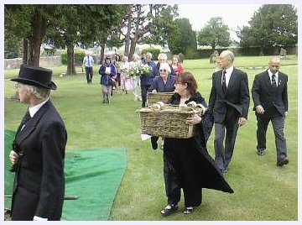
The skeletal remains of at least four individuals were reburied at Highworth Cemetery on 21 June 2007. Two of these ancestors are Bronze Age partial skeletons, around 4000 years old, that were found during building work at Wrde Hill in Highworth in September 1977. Both were in a crouched position, with hands across the chest. Excavation was haphazard: no formal dig was carried out, local amateurs and enthusiasts working on the site, sometimes late into the night in order to accommodate the builders who asserted severe pressure. Partly damaged by the diggers, the remains, including a skull, pelvic and other bones, were taken into the care of Highworth Historical Society, and have been kept by members of the Society over the years. It appears that the whole of Wrde Hill may have been built on an old burial site as more remains were found close by, the bones going to the Devizes Museum and possibly to Swindon Bath Road Museum (records are not clear).
The full Romano-British skeleton, locally known as Yorik, was exhumed from a garden in the town in 1965 when the householders were burying their pet dog. When the bones emerged, the police were informed but were not interested. Local amateur archaeologist, Mike Collins, exhumed the remains, together with Mike Stone, curator of Chippenham Museum, with the help of Chris Chandler who was then senior archaeologist for Wiltshire. However, nobody seemed to want the remains, which stayed in the care of the householders until they moved house, when Yorik was passed to the Historical Society. Never accessioned to a museum, Yorik has been on display a number of times over the years, at festivals and local exhibitions.
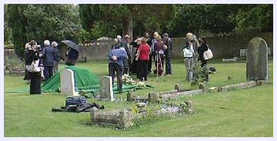
The other remains reburied on 21 June were found in a medieval enclosure ditch at Haresfield locally, in the late 1970s. These, also excavated by Mike Collins, have been dated as late medieval. As some of the bones are thought to be human, the Historical Society felt they would take no chances and treat them as if they were.
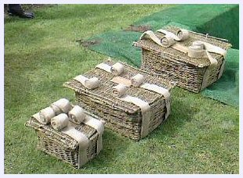
Indeed, it was only when members of the Historical Society attended a course on storing and archiving artefacts that they felt they really ought to do something about these remains. They sought expert advice from a local Records and Archaeological Service. Following the Human Tissue Act and the publication of the DCMS Code of Practice, the Society understood they would not be able to provide these ancestors with what was now required. In part they were misinformed, believing that elements of the HTA legislation applied to these remains; HAD is aware of a good number of museums and other small heritage organisations that are equally confused.
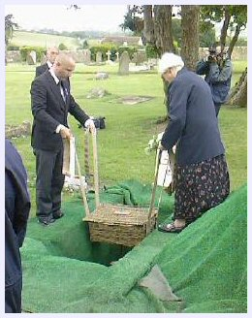
Misinformed or not, however, the Highworth Historical Society discussed the issue and came to an agreement that all the human remains in their care should be reburied. Highworth has no museum. If it had, and could have afforded the adaptations to keep them, the reburial may not have happened - particularly of Yorik. However, speaking to Jo Clark, the Society's secretary, I got the impression that her inclination was towards reburial. This was 'the honourable and decent thing to do', the 'correct' thing, she said, choosing her words carefully in order to find that which most accurately expressed her inner moral voice. 'The Society decided that it would be appropriate if the remains were re-interred in the area in which they were originally lain to rest ... We believe this is a fitting end for these men who probably lived and worked in or around Highworth many centuries ago.'
The important issue here was that the society was under no pressure from anyone to retain the remains. They felt it was entirely their choice. In their opinion, the bones had been contaminated by too many hands to be of any scientific value. Local museums were not interested. Reburial was the natural decision in order to ensure there was decency and respect.
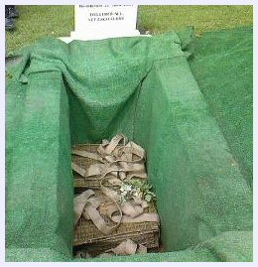
The remains were reburied at the town's local authority cemetery, land with beautiful views of the Wiltshire countryside, not consecrated by the Church. The short nondenominational ceremony was conducted by an elder of the United Reformed Church using beautiful non-religious words that honoured the lives of these ancestors, acknowledging them still to be a part of the Highworth community. They were treated as people, or 'persons' in the philosophical sense, not objects. Wrapped in locally produced woollen cloth and laid in three environmentally-sound willow baskets, the remains were buried in one plot, beside an ancient trackway in an older part of the cemetery not currently used for burial. A headstone marks the grave with an inscription that describes those buried, ending with a quote by Christina Rossetti, 'Together all, yet each alone'. With the remains were buried some locally sourced mead, honey and a bread roll, as 'sustenance for the journey'. Each has a 2007 copper coin from the Royal Mint and leaves from seven plants sacred in the Druid tradition: vervain, henbane, primrose, pulsatilla, clover, mistletoe and wolf's bane (monkshood). Every effort had been made to ensure there was a profound sense of respect. Indeed, in many ways, the burial felt not dissimilar to that of someone who had recently died. There were tears on the cheeks of some who had gathered.
Many museums worry about the price of deaccession and interment, using this as another deterrent to the process of reburial. In this case the funeral director did not charge for the event at all, nor did the local authority charge for the grave space. The gravedigger's fees were cut by two thirds to £100. The monumental masons donated the headstone, the minister charged no fee, and the flowers came from the local Floral Art Society. Indeed, the total cost, including the baskets, a little oasis for the flower arrangements, was no more than £210.
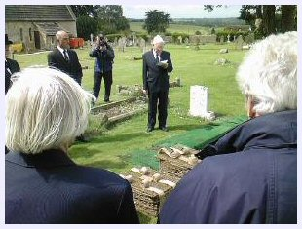
What are the lessons for HAD when it explores the possibilities of reburial with archaeologists and museums?
In one sense, this case is not typical, since the remains were held by an autonomous local society, rather than by an archaeological field unit or a museum. In other senses, however, there are significant lessons. Highworth powerfully demonstrates the strength of local feeling towards reburial of human remains, especially those with no demonstrable scientific value. It also shows that reburial need not be an expensive process: other parts of the local community in Highworth, including the local authority, became inspired by the idea of reburial and willingly provided practical assistance at no or considerably reduced cost. This is surely the key inspiration not only for HAD but for all museums and heritage organisations considering reburial: if the local community is involved in the decision-making process and the practical arrangements for reburial, then the value of reburial, even (or especially) of much-loved local remains, is broadly crucially understood, and will be much inspired by local support.
Emma Restall Orr, June 2007

Appendix C: Burial of Bones used for Medical Education

Genuine human bones, articulated into full or partial skeletons, smaller sections of human anatomy or as single bones, were regularly brought into Britain over hundreds of years, to be used in medical education. The majority are believed to have come from India during the days of the British Empire, being those of criminals, paupers or victims of crime, where any existing family were unable or unwilling to step forward to claim the body at the time of death. Some were sold, some simply taken, but with no records of consent the trade was clearly unethical. In 1985, the practice was eventually made illegal by the Indian government.
However, unlike human remains disinterred during documented exhumations and archaeological digs, where the provenance may be clearly known and repatriation a possibility, human bones used in UK medical establishments almost always have no clear provenance. Indeed, skeletons are known to have come from Africa, China and all across Asia.
In the meantime, in Britain, with a growing recognition of this lack of ethics, it has become increasingly unacceptable for genuine bones to be used in medical education. However, it is estimated that there must be tens of thousands of human skeletons in cupboards, boxes, drawers and attics, that are no longer used in lecture theatres.
In the autumn of 2025, the problem became apparent to a Dr M in Warwickshire. She had been given an articulated upper body skeleton, with intact arms and full skull, when she went to medical school. Her daughter followed her into medicine, using the skeleton in her studies. It proved useful to fellow students of both generations, and others studying anatomy over the years. It was even taken into the local primary school.
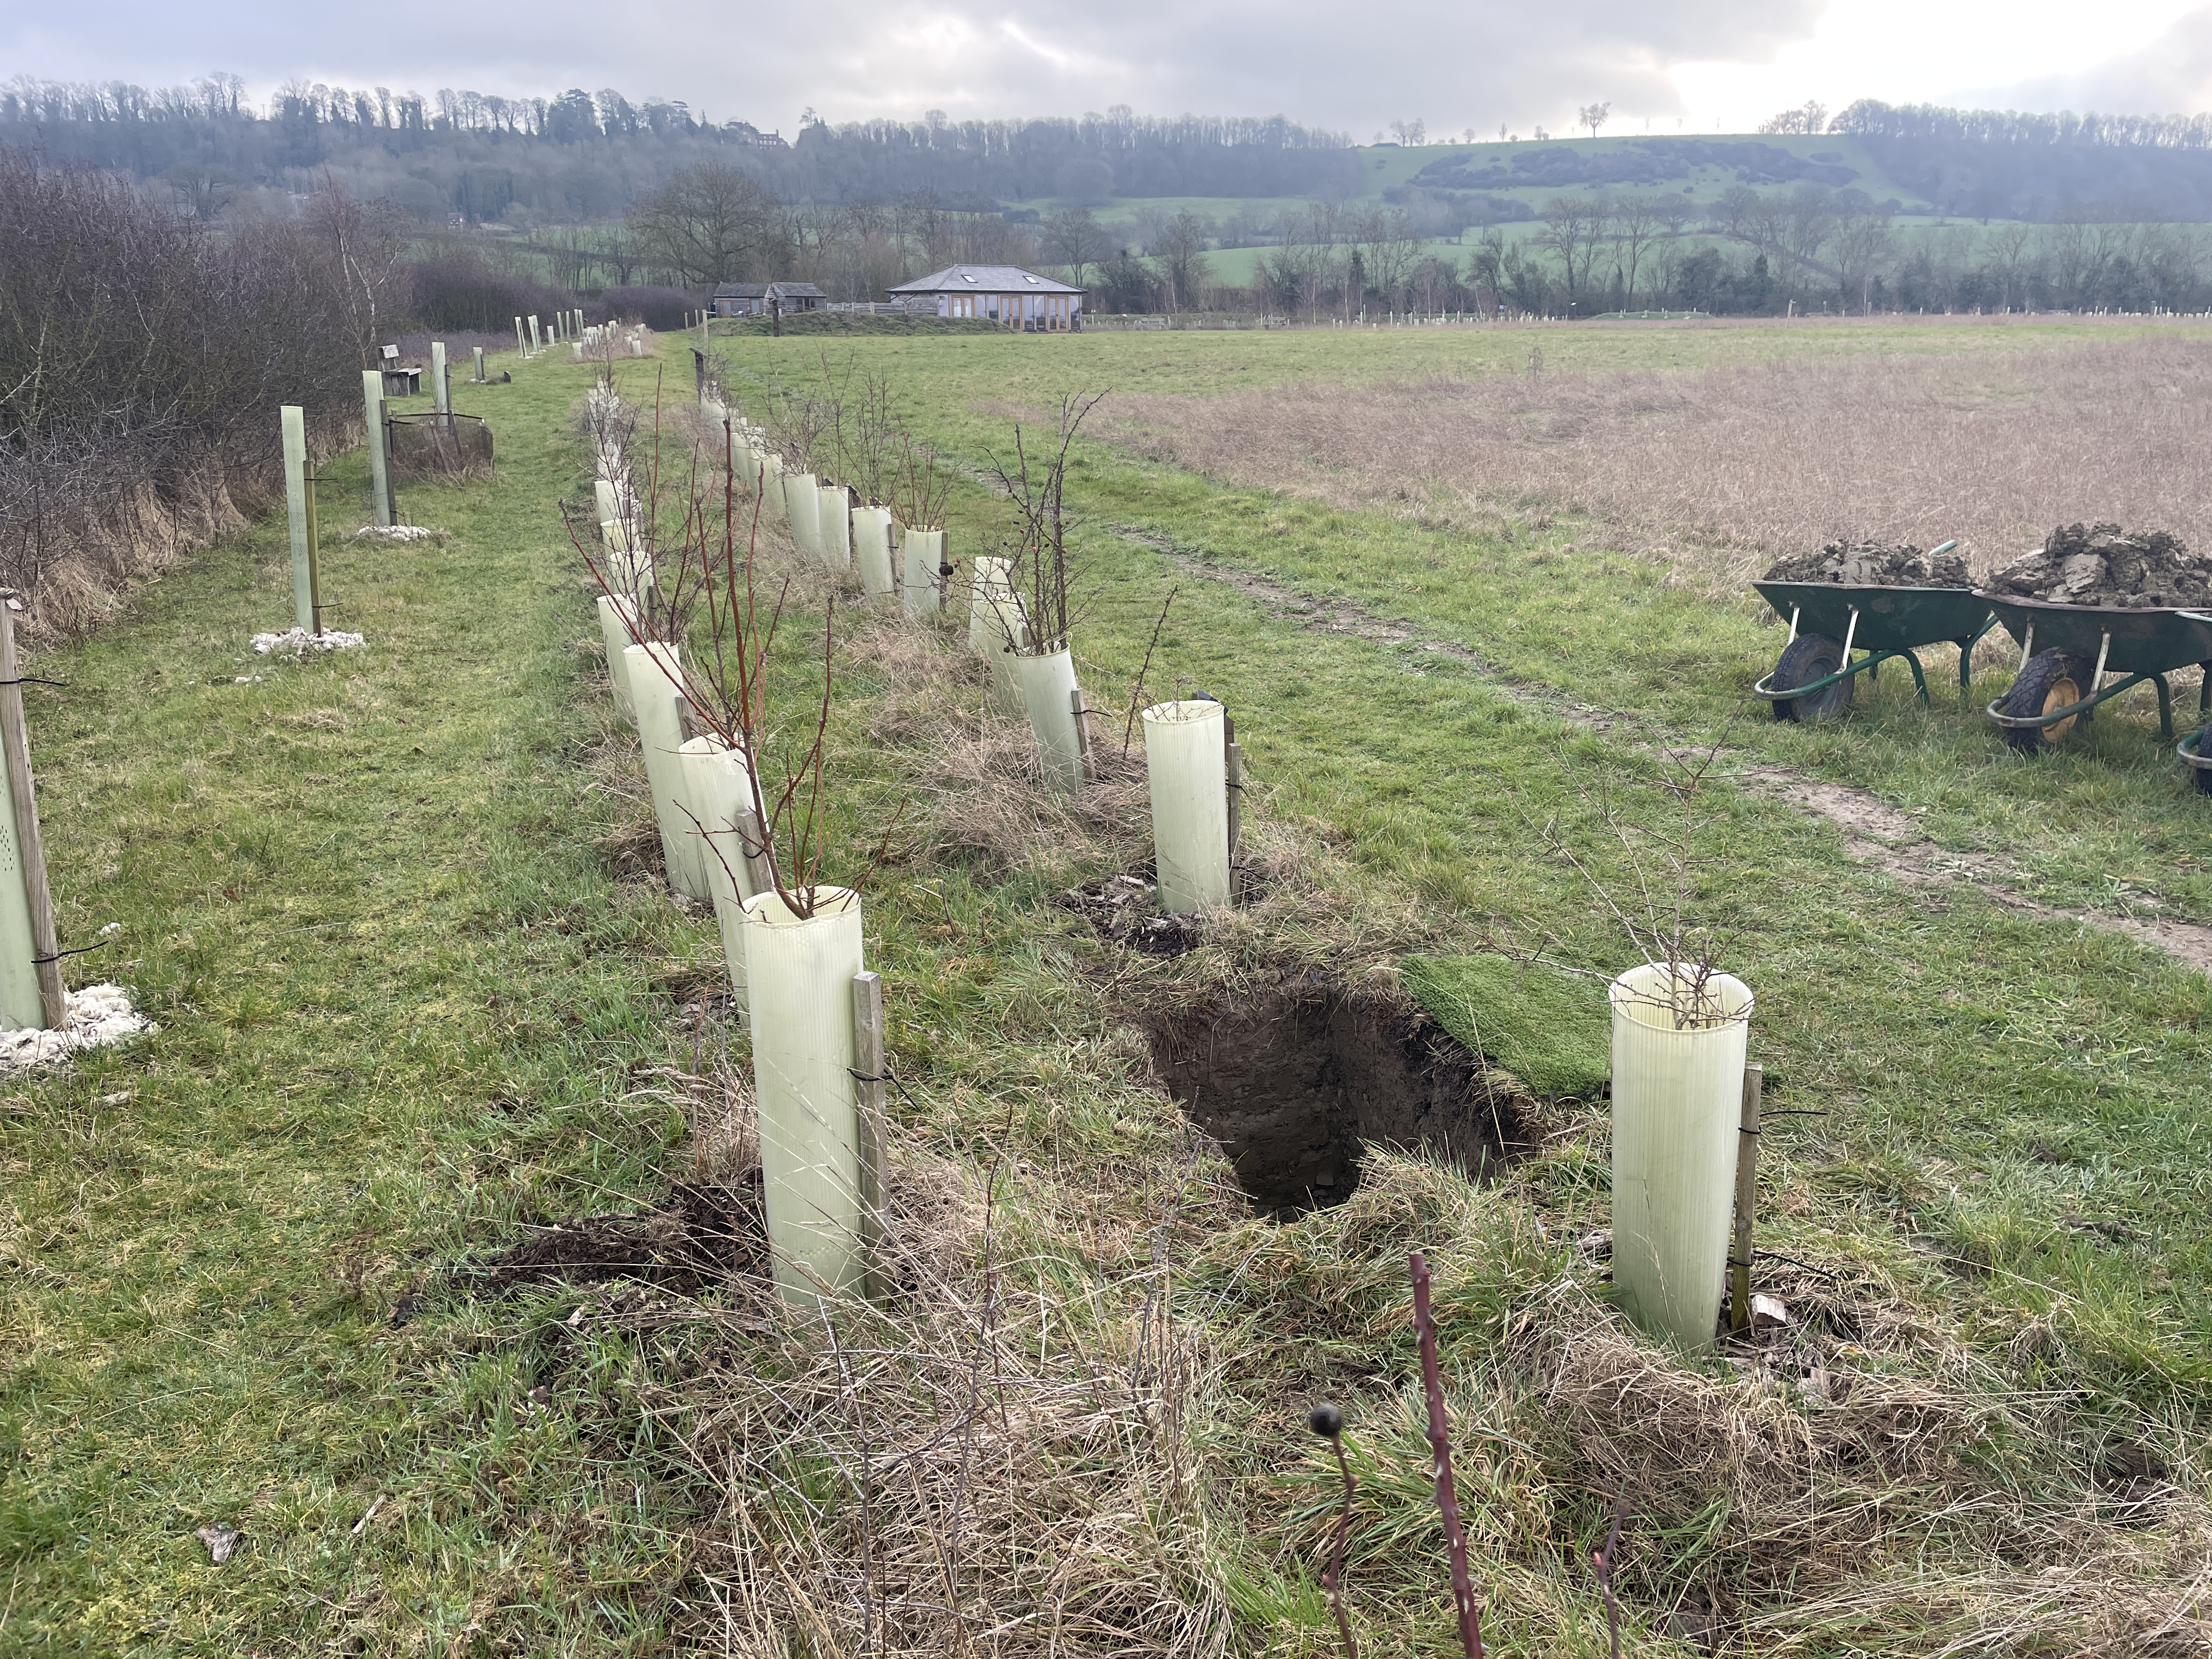
When Dr M felt she wanted to let go of the skeleton, it occurred to her that there must be a respectful way of doing this. She called her local independent funeral director, R Locke and Son, who had never fielded such an enquiry before. The funeral director owner called the manager at the local natural burial ground, Sun Rising. Between the funeral director and burial ground, a plan was arranged.
Virtually nothing was known about the skeleton, no scientific testing having taken place on the bones, other than that it was an adult male.
Funding
The funeral director was happy not to charge Dr M anything for their part in the arrangements. Colin, the semi-retired owner of the firm, carried out most of the work, which gave him more scope to be adaptable. To him, being involved was a natural part of his firm’s role in the community. The age, condition and origin of the skeleton made no difference to his desire to look after the dead.
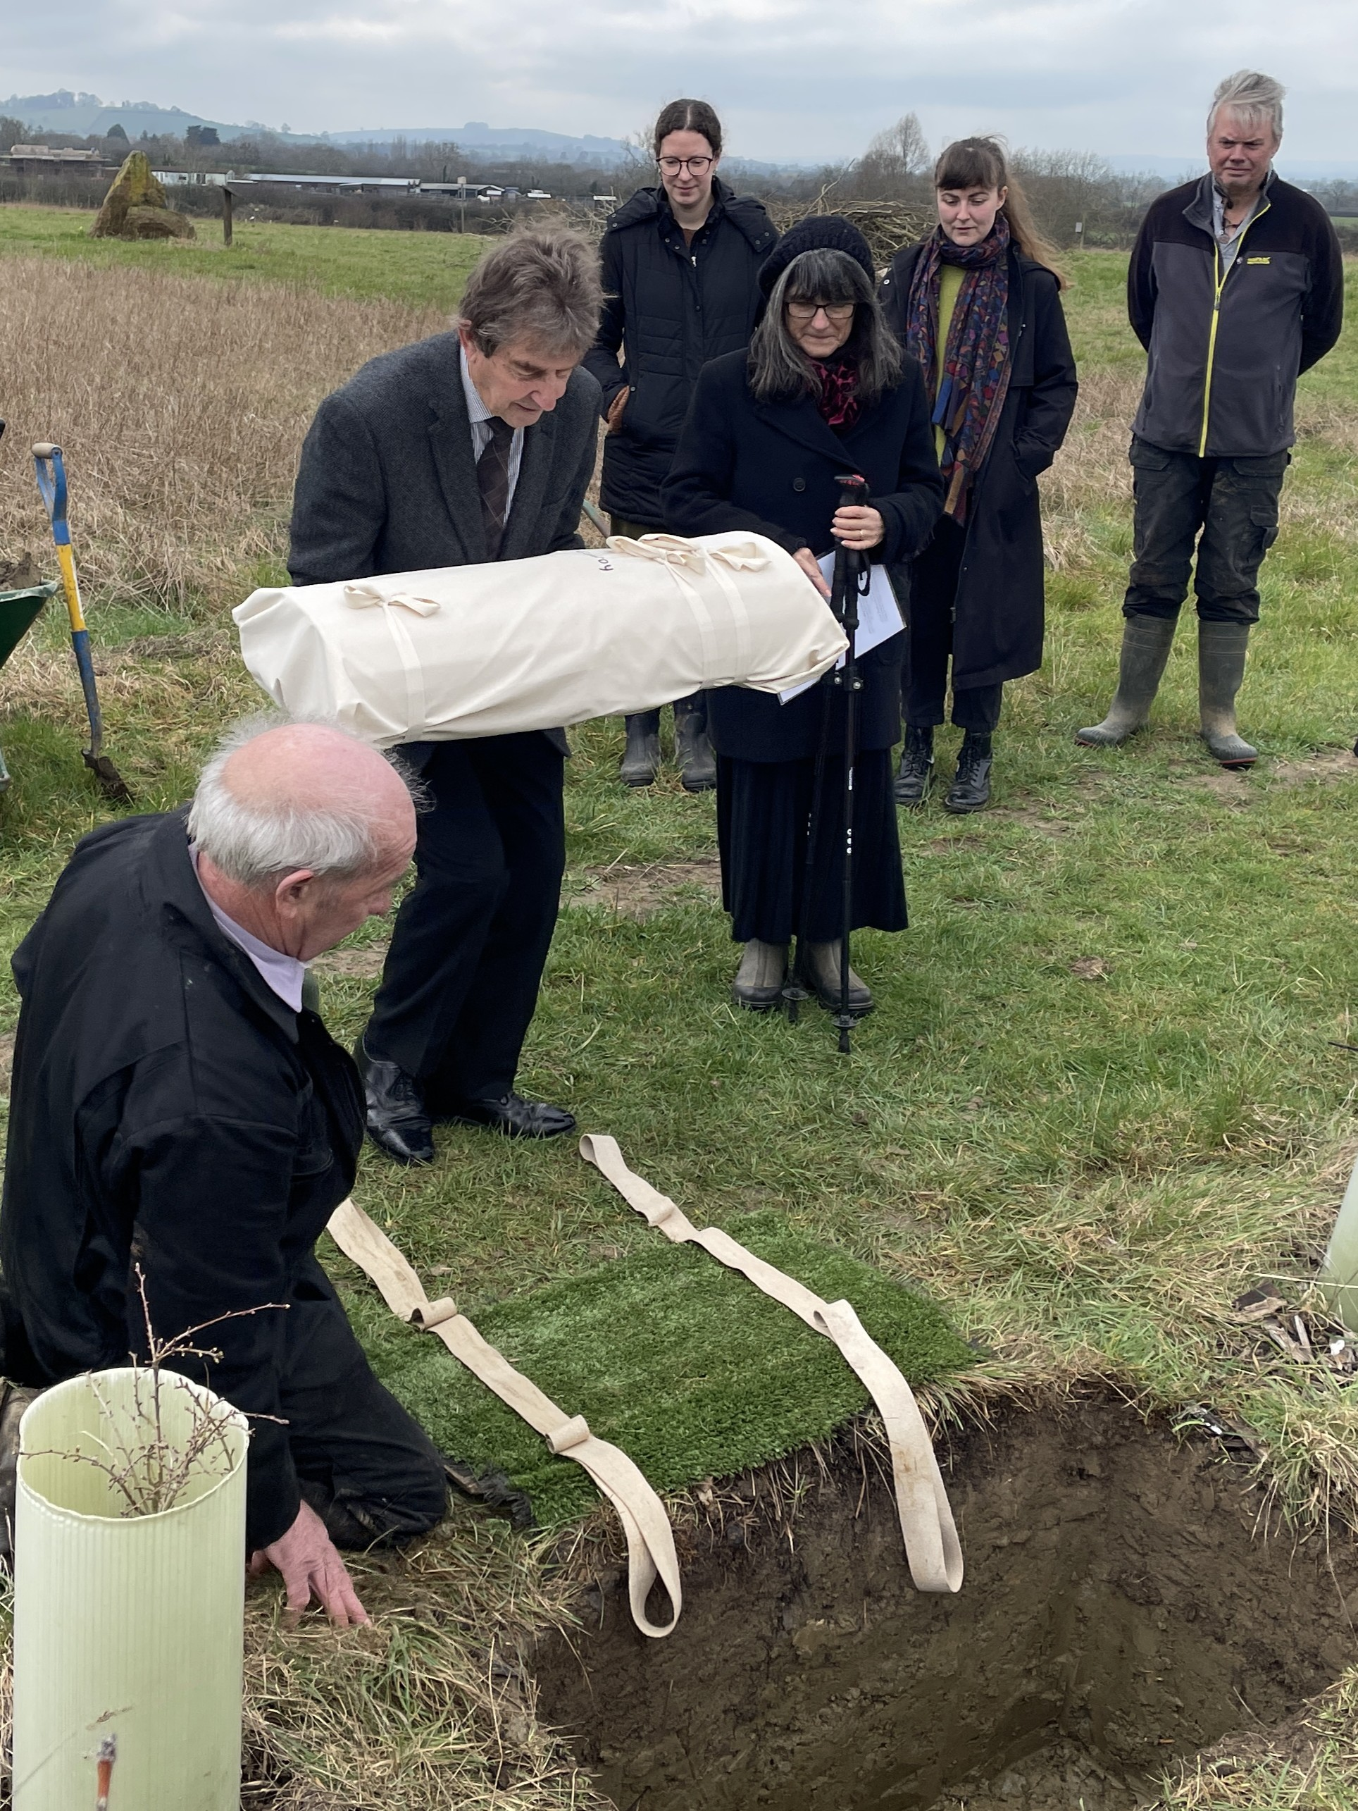
Instead of buying in a coffin or other ready-made container, his team laid the skeleton on a cardboard base, securing further card around it in order to create an envelope. The whole was then wrapped and secured in calico. There was minimal outlay to him for these materials.
The natural burial ground was equally happy to be involved. Because it was a dry skeleton that was to be buried, it was possible to find a location within their grounds which would have been unavailable for burial of someone newly deceased. This meant that they could offer the plot without charge. The grave was dug by one of the funeral director’s team together with one of the burial grounds, so no charge was made for this service either.
Dr M was given the option of a small slate memorial plaque, of the type widely used at Sun Rising, if she wanted the spot to be marked. She chose to do this, and this was the only element for which she needed to pay.
Practicalities
The skeleton has a few small sections of wire that kept it articulated, but the natural burial ground felt these need not be removed: while not biodegradable, they were not toxic. The card and calico wrap, being fully biodegradable and non-toxic, was also passed as acceptable by Sun Rising.
The plot location chosen was along a loose hedge of young shrubs and trees planted about five years previously. Where a hawthorn had died, there was a perfect space for a small grave. The spot had a marvellous view over the rural landscape to the far hills. The plaque would be installed on the hedge edge, where there were other plaques in memory of loved ones.
The final size of the wrapped bundle came to 33” x 14”, with a depth of 10”. The grave was dug to fit, to a depth of 22”, there being no reason to dig deeper in the clay soil with the bones giving off no scent.
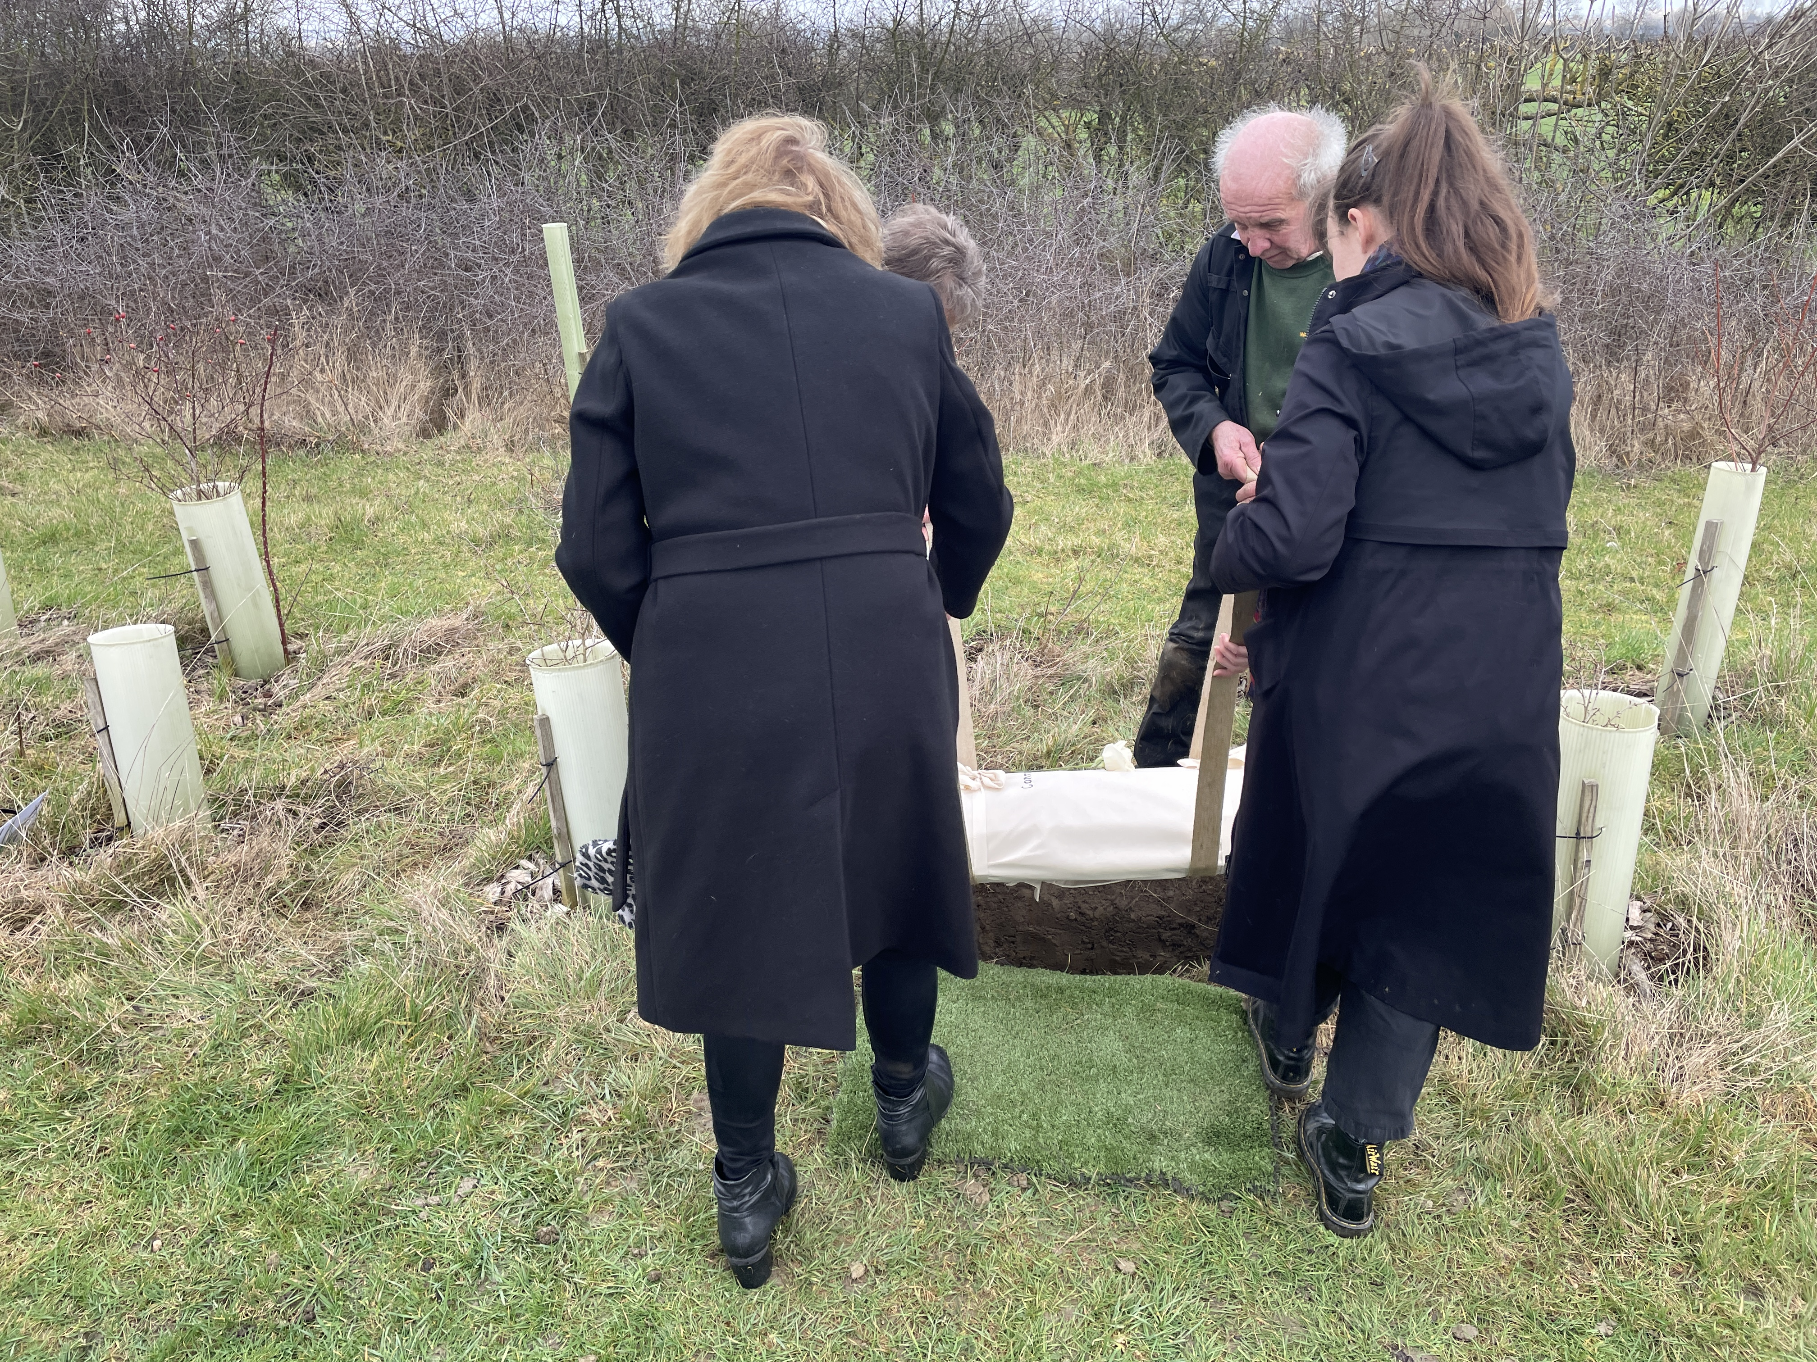
With regard to paperwork, the burial ground used a customised version of the Burial Record for a Privately-Owned Burial Ground form – Appendix D. This was completed by Dr M, providing all the information she had about the skeleton’s origins. The funeral director filled in his part, and the form was given to the burial ground to sign and keep in their records. The plot was marked on their register with the relevant information.
Although the skeleton’s original name was, of course, unknown, and Dr M had not named him over the years of his being in her care, the team at Sun Rising felt he needed a name, in order to further acknowledge him as an individual human being. They named him Conroy, a name that speaks of teaching, because his bones had taught so many.
The Burial
The day was a beautiful day in late winter, with blue skies, dunnocks and blackbirds singing in the hedgerow, the first skylarks and curlews across the meadows. The plot was dug and ready when Dr M arrived, the funeral director with Conroy, and the whole burial ground team who wanted to be present.
Emma, the manager at Sun Rising, read the words she had written in preparation, acknowledging the situation: none present had been instrumental in what had happened to the fellow at the time of his death, none knew his culture, his religion, or what burial rites he should have had, none knew his name or the landscapes of his birth, his life and his death. Nonetheless, it was hoped that the respect shown at this time of his burial would in some way reflect back. If Conroy did, perhaps, have descendants, perhaps great grandchildren or great great grandchildren, alive somewhere, it was good to feel that they might be touched by the gratitude shown for all that he had unknowingly given to so many as they learned about human anatomy.
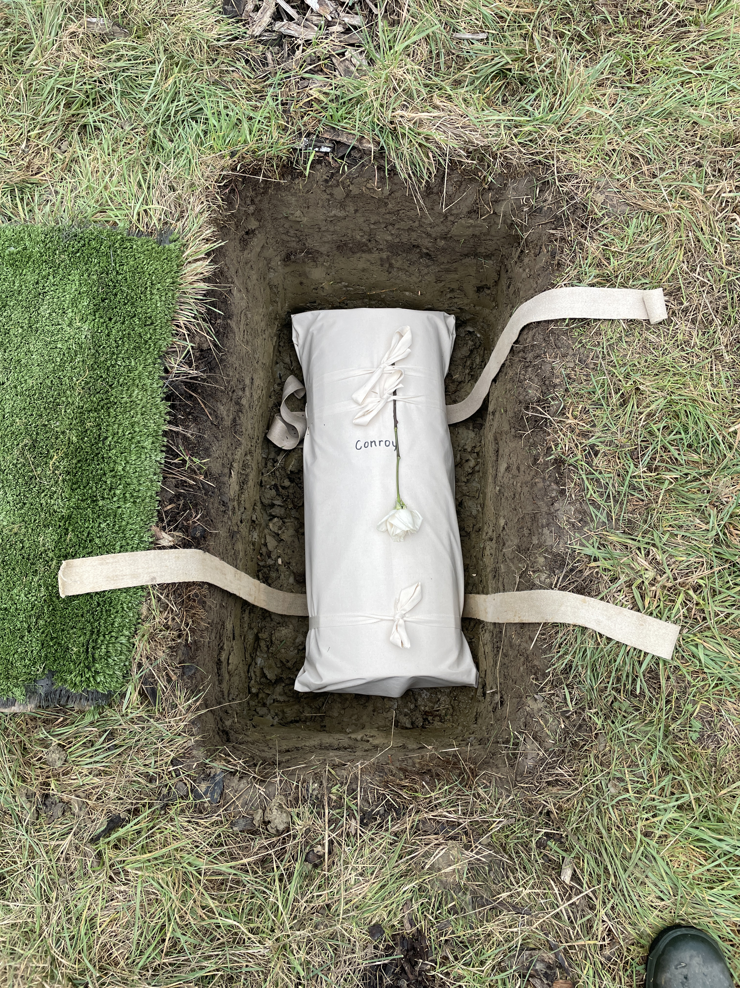
The event was tender, moving and important to all who had been involved. Those who had dug then backfilled, ‘tucking him in’, where he now lay, in front of cherry trees, hawthorn, hazel and dogwood. His plaque reads, ‘In gratitude for all you gave to medical education.’
Dr M wished to remain anonymous throughout the process. While in no way a condition of the burial process, both the funeral director and burial ground were named in a press release and social media that was posted afterwards. The impetus for this publicity was to encourage others: after the burial, Dr M said she knew many others who still had human skeletons in their care. She hoped they could let them go as she had, with thanks, and with respect for them as individual human beings.

Appendix D: Burial Record for a Privately-Owned Burial Ground

This form is to be used for the burial or reburial of human material in a private cemetery or burial ground, where the material is agreed to be of no relevance to the coroner’s office. This may include, for example, (1) human bones deaccessioned from a museum collection or released from an archaeological store, being over 100 years old, or (2) human bones that have been used in medical education, which may be less than 100 years old but have no clear origin, no name or known provenance.
It takes the place of a Green Form or Coroner’s Order Part C that should be returned to the local register office, instead simply being kept as part of the burial ground’s records of burial, additional to the Burial Register.
The form’s questions can be copied from this handbook and formatted in the style of the private burial ground. The words in parentheses in italics simply give an example of what might be included.
Description of human remains:
- Twenty-five human bones, being 4 carpals, 3 metacarpals, partial ulna, partial radius, 12 partial ribs, various other large fragments, all discoloured with age, presumed to be from one individual)
- Loosely articulated upper-body skeleton, including right pelvis bone, with skull and lower jaw, unpolished, all non-natural connecting materials removed, no attached labelling)
Name used for the individual:
- None)
- Staff have called the skeleton Bertie, though it is not known how long this name has been in place.)
In whose care have they been and since when:
(1. The box with all these bones was given to Wellesly Museum at some point in the mid-1950s, although there is no exact date recorded.)
(2. Royal County Hospital, Lerchester, anatomy teaching department, earliest known records stating that the skeleton has been in the department since the 1960s.)
What is known of the history of the individual before that time:
(1. It is understood that the box was found in the attic of local antiquarian, Mr Charles Smith, by his daughter at the time of his death in 1953, who brought it to the museum when she sold the house. Various archaeological tools dating back to the early 20th century were accessioned together with the bones.)
(2. There is no recorded information about Bertie before this time, but he was thought to have been brought back from India in the 1920s by a private physician.)
Any other information about the individual’s provenance or physical remains:
- There is no information about these bones, and it is believed no research has ever been conducted on them. As they have no provenance, research would bring no useful information.)
- No analysis has been done on the bone to establish provenance; however, the extant bones imply a male of around 5’6 in height, who suffered from poor nourishment, and a small degree of scoliosis. Two ribs are cracked, but this is assumed to have been damage caused while the bones were in the care of the teaching department.)
Under whose authority are the remains released for (re)burial:
(1. Mrs Helen Fielding, Senior Curator, Wellesly Museum)
- Mr Edward Barns, Consultant Osteologist, Royal County Hospital, and Professor Deborah Jones, Anatomist, Royal County Hospital, Lerchester)
Signed by the above:
Dated:
These human remains are accepted into the care of [name of the burial ground or cemetery) by:
(name)
Signed:
Dated
Date of (re)burial:
(date)
Information about the casket or container which will be used for the burial:
(1. Cardboard box decorated by members of the Lerchester WI.)
(2. Cardboard sleeve inside willow casket, donated by local willow basket maker, Ms Susan Haywood)
External measurements of casket or container (length, width and depth):
(size)
Any further information:
(1. A small rose quartz pebble has been placed in the box, donated by junior museum staff who felt a symbol of care was needed.)
(2. Also inside the casket are letters of thanks written by anatomy students in the hospital.)

Museums Association. ‘Off the Shelf’: a toolkit for ethical transfer, reuse and disposal’. https://www.museumsassociation.org/campaigns/ethics/disposal/#
Museums Association. ‘Code of Ethics’. https://www.museumsassociation.org/campaigns/ethics/disposal/#.
‘Reburial’ – may relate to the reinstatement of inhumations, cremations and other methods of original committal of the dead. It is equally feasible to follow this guide for burial of human remains where an original inhumation has never taken place.
Advisory Panel on the Archaeology of Burial in England. Guidance for Best Practice for the Treatment of Human Remains Excavated from Christian Burial Grounds in England. First published 2005; Second edition published 2017. Available from: https://apabe.org.uk/sites/apabe.org.uk/files/2024-08/APABE_Excavated_Remains_Best_Practice.pdf.
See section 2.2. of the Museums Association ‘Code of Ethics’ https://www.museumsassociation.org/campaigns/ethics/disposal/#.
HAD can assist with contacts within Pagan faith communities
Museums Association. ‘Code of Ethics’ https://www.museumsassociation.org/campaigns/ethics/disposal/#.
For the purposes of this document, we assume that it is not standard practice to deaccession grave goods at the same time as reburying an ancestor. We do recommend considering whether it would be appropriate to include any grave goods, either replicas, or modern tokens that feel appropriate to the community. Questions around suggested grave goods could be done as part of consultation and general planning for reburial.

